Nepal College of Information Technology
Assessment
Fall 2010
Program: CE/IT Time: 3 hrs
Semester: Fall (V) FM: 100
Subject: Numerical Methods PM: 50

The figures in the margin indicate full marks.
Attempt all the questions:
1 a) Solve
3x+sin x-e^{x}=0 by secant method. Correct to 3 decimal places. [7]
b) Solve
e^{x-1}-5x³=0 by Newton-Raphson method correct to three decimal places. [8]
2. a) Construct the Lagrange interpolation polynomial with the data in the following table
[7]
x | -1 | 0 | 2 | 5
f(x) | 10 | 7 | 7 | 22

b) Fit an equation of the form y=ae^{bx} to the following data by the method of least squares
[8]
x | 1 | 2 | 3 | 4
y | 1.65 | 2.7 | 4.5 | 7.35

3. a) Evaluate 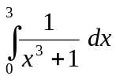 by
i) Trapezoid Rule
ii) Simpson's Rule
iii) Simpson's Rule [7]
b) Evaluate
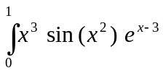
by Gaussian two and three term formulas. [8]
4. a) Solve
x+2y+z-w =-2
x+y+3z-2w =-6
2x+3y-z+2w= 7
x+y+z+w = 2
by Gauss elimination meyhod. [8]
b) Find the dominant eigen value & corresponding eigen vector of the matrix by power method.
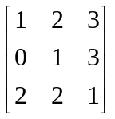 [7]
5. a) Solve the differential equation
=sin x+y, y(0)=2 by RK-4th order for y(0.2) [8]
b) Solve
y"-x² y'-2xy=0 for y(0.1) & y' (0.1) given that y(0)=1, y'(0)=0, by using Huen's method.
6. a) Solve
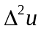=-10 (x²+y²+10) over the square mesh with sides x=0, y=0, x=3, y=3 with u=0 on the boundary & mesh length =1. [10]
b) Find the missing value of the table
[5]
x | 1 | 2 | 3 | 4 | 5
f(x) | 0 | 7 | 26 | - | 124
7. Write short notes on (Any two): 2*5=10
a) Convergence of fixed point iteration method
b) Fitting of curve
c) Matrix factorization.

